**KISII UNIVERSITY**

**SCHOOL OF PURE AND APPLIED SCIENCES**

**DEPARTMENT OF MATHEMATICS AND ACTUARIAL SCIENCE**

VOLATILITY MODELING OF THE KENYAN SHILLING/USD EXCHANGE RATE: A GARCH APPROACH

*A Research Project Submitted in Partial Fulfillment of the Requirements for the Degree of Bachelor of Science in Actuarial Science*

**By:**

**ALICE ATIENO: PS10/00097/21**

**DENNIS MWANGI WAMBUI: PS10/00007/21**

**MATILDA ACHIENG: PS10/00083/21**

**PHILLIP LETEIPA: PS10/00050/21**

**SUPERVISOR: DR WALTER ONCHERE**

**DATE:**

# DECLARATION

We, the undersigned, declare that this research project titled: “VOLATILITY MODELING OF THE KENYAN SHILLING/USD EXCHANGE RATE: A GARCH APPROACH”, is our original work and has never been presented for a degree or any other academic qualification in any institution. We confirm that this work has been done according to the academic rules and regulations of Kisii University for the Award of Bachelor in Actuarial Science in accordance with the academic rules and regulations of Kisii University.

**SUPERVISOR’S DECLARATION**

This research project has been submitted for examination with my approval as the university supervisor.

**Supervisor’s Name:** Dr.Walter Onchere **Signature: ___________  
Date: ______________**

# DEDICATION & ACKNOWLEDGMENTS

We dedicate this research project to our families, friends, and mentors who have supported us all throughout our academic journey. You have been our pillars of strength throughout this journey. Your support, encouragement, and belief in us cannot go unappreciated.

We also extend our heartfelt gratitude to our supervisor, Dr. Walter Onchere, for his invaluable guidance, patience, and constructive feedback, you have greatly contributed to the success of this project.

Additionally, we appreciate our lecturers, and Kisii University for providing us with the knowledge and resources necessary to undertake this research. Above all, we are grateful to God for granting us the strength, wisdom, and perseverance to complete this work.

# Table of contents

Contents

DECLARATION 2

DEDICATION & ACKNOWLEDGMENTS 4

Table of contents 5

List of figures and tables 5

Abstract 8

CHAPTER 1: INTRODUCTION 10

Background of the study 10

Statement of the problem 13

Objectives 14

Significance of the study 15

2.LITERATURE REVIEW 15

Empirical review 16

Theoretical review 27

Random Walk Process theory 27

THE STOCHASTIC PROCESS THEORY 28

Efficient Market Hypothesis (EMH) 30

Volatility Clustering in Exchange Rate Modeling. 32

CHAPTER 3: METHODOLOGY 34

Introduction 34

Data collection and preprocessing 34

Model specification and selection 35

ARMA order selection 36

GARCH Order Selection 36

Distribution Selection 36

Selection Criteria And Final Model Choice 37

Model estimation and diagnostics 37

Residual Analysis 38

Forecasting volatility and validation 38

Metrics Of Forecast Evaluation 38

Software And Tools 39

CHAPTER 4: RESULTS AND ANALYSIS 39

INTRODUCTION 40

Preliminary Analysis 40

DCC-MGARCH 41

SGARCH model results 45

PGARCH (APARCH) model results 49

TGARCH model results 53

EGARCH model of results 56

Model forecast validation 60

Discussion of findings 61

CHAPTER 5: CONCLUSION AND RECOMMENDATIONS 62

Introduction 62

Summary of the findings 62

Model performance: 63

Residual diagnostics 63

Forecasting accuracy 64

significance of the findings; 64

Limitations of the study 65

Recommendations 65

Conclusion 66

References 67

# List of figures and tables

Figure 1. Plot of log returns 41

Figure 2. log returns plots for series 1 and 2 42

Figure 3. table of forecasted volatilities 43

Figure 4 graph of the forecasted volatilities 44

Figure 5Forecasted correlation 45

Figure 6 DCC GARCH ACF OF RESIDUALS 45

Figure 7SGARCH forecast volatility graph 47

Figure 8 SGARCH TABLE OF FORECASTS 48

Figure 9 SGARCH ACF of residuals 48

Figure 10 SGARCH RESIDUALS 49

Figure 11 PGARCH TABLE OF FORECASTS 50

Figure 12 PGARCH FORECAST GRAPH 51

Figure 13 PGARCH ACF OF RESIDUALS 52

Figure 14 PGARCH PLOT OF RESIDUALS 52

Figure 15 TGARCH TABLE OF FORECASTS 54

Figure 16 TGARCH PLOT OF FORECASTS 54

Figure 17 TGARCH ACF OF RESIDUALS 55

Figure 18 TGARCH PLOTS OF RESIDUALS 56

Figure 19 EGARCH TABLE OF FORECASTS 57

Figure 20 EGARCH FORECASTS PLOT 58

Figure 21 EGARCH ACF OF RESIDUALS 59

Figure 22 EGARCH PLOT OF RESIDUALS 60

# List of Abbreviations

* ADF – Augmented Dickey-Fuller
* AIC – Akaike Information Criterion
* APARCH – Asymmetric Power Autoregressive Conditional Heteroskedasticity
* ARIMA – Autoregressive Integrated Moving Average
* ARMA – Autoregressive Moving Average
* ARCH – Autoregressive Conditional Heteroskedasticity
* BIC – Bayesian Information Criterion
* CBK – Central Bank of Kenya
* DA – Directional Accuracy
* DCC-GARCH – Dynamic Conditional Correlation Generalized Autoregressive Conditional Heteroskedasticity
* EGARCH – Exponential Generalized Autoregressive Conditional Heteroskedasticity
* GED – Generalized Error Distribution
* GARCH – Generalized Autoregressive Conditional Heteroskedasticity
* KES – Kenyan Shilling
* MAPE – Mean Absolute Percentage Error
* MGARCH – Multivariate Generalized Autoregressive Conditional Heteroskedasticity
* MLE – Maximum Likelihood Estimation
* PGARCH – Power Generalized Autoregressive Conditional Heteroskedasticity
* RMSE – Root Mean Squared Error
* SGARCH – Standard Generalized Autoregressive Conditional Heteroskedasticity
* TGARCH – Threshold Generalized Autoregressive Conditional Heteroskedasticity
* USD – United States Dollar

# Abstract

Exchange rate volatility plays an important role in financial markets, affecting economic stability, investment strategies, and policy decisions. This study models the volatility of the Kenyan Shilling (KES) against the US Dollar (USD) using various GARCH models, these are S-GARCH, E-GARCH, T-GARCH, P-GARCH, and M-GARCH, to determine the most effective model for capturing and forecasting exchange rate fluctuations. The objectives of this study are to evaluate the performance of these models, analyze asymmetric effects, and identify the most reliable forecasting approach.

Daily exchange rate data from the Central Bank of Kenya was used, starting from January to December 2024. The data was preprocessed using log differencing to ensure stationarity, and model selection was automated using the Akaike Information Criterion (AIC) for prediction purposes. The study employed an ARMA-GARCH framework, where optimal ARMA orders and GARCH specifications were determined using the rugarch and rmgarch packages in R. Model validation was performed using Root Mean Squared Error (RMSE), Mean Absolute Percentage Error (MAPE), and Directional Accuracy (DA).

Findings show that all GARCH models successfully capture volatility clustering, with E-GARCH and T-GARCH effectively modeling asymmetric effects. However, S-GARCH emerged as the optimal model due to its great performance in forecasting accuracy, achieving the lowest RMSE and highest directional accuracy. The results emphasize on the importance of selecting an appropriate volatility model for exchange rate prediction, they offer valuable insights for risk management, monetary policy formulation, and financial decision-making in emerging markets.

# CHAPTER 1: INTRODUCTION

## Background of the study

Kenya’s fiscal system is highly dependent on the exchange rates between the Kenyan shillings (KES) and US Dollar (USD) as one of its greatest economic indicators. This is due to the heavy reliance on foreign investment and international trade by Kenya as a country. The value of the Kenyan shilling in comparison to other foreign currencies such as the USD is an indicator of the economic position of the country. Imports and exports are mostly exposed to effect by exchange rates which affect the balance of payments, inflation rates and economic growth. Omondi (2020) states that the pivotal role of the USD in global trade and the importation of its essential goods by Kenya indicates that any changes in the KES/USD exchange rate could lead to major economic consequences.

For instance, a depreciation in the Kenyan shilling against the US Dollar leads to increase in prices of important goods which may contribute to inflation. Consumers may be left with no choice but to deal with increased costs of living while businesses that rely on imported inputs facing increased operating costs. Conversely, an appreciation of the Kenyan shillings may reduce inflation but in turn negatively affect the export power as the Kenyan products become unaffordable to the foreigners. As a result, the KES/USD exchange rate directly affects both the macroeconomic and microeconomic environment (Kariuki, 2017).

**Exchange rate volatility and its economic impact**

In the past years, there has been some significant fluctuations in the KES/USD exchange rates which are associated to both international and domestic factors. Domestic factors that affect exchange rate volatility include inflation, interest rates, monetary policies and the political stability of the country. For example, inflation pressures could weaken the value of the Kenyan shillings as high inflation rates affect the purchasing power. Changes in interest rates mostly the ones set by the Central Bank of Kenya majorly affect the foreign investment flows (Wekesa & Were, 2022). Higher interest rates could attract foreign investments which would in turn cause the Kenyan shilling to appreciate, while low interest rates could in turn cause the depreciation of the Kenyan shilling.

Political instability is significant domestic factor which influence exchange rate volatility. During times of civil unrest and political uncertainty, chances of investors withdrawing their capital from the country increases due to fear of instability and losses in cases of destruction of properties. According to Mutisya and Makau, 2016) capital flight such as this may increase downward pressure on the exchange rate which would in turn lead to depreciation of the Kenyan shilling. Excessive borrowing and increased dept pool by the government may cause foreign investors to lose confidence in the country’s ability to repay debts leading to depreciation of the shilling’s value (Njoroge, 2019).

Some external factors such as prices of goods, US monetary policies and geopolitical events have an influence on the KES/USD exchange rate. Importation of global commodities such as oil may directly influence the exchange rates (Owino, 2021). The US Federal reserve makes monetary policy decisions which have a significant influence on the KES/USD exchange rates. According to Mungai and Wanjohi (2023), Raising of interest rates by the Federal Reserve could attract capital flow to the US which could strengthen the USD while weakening the KES since investors will invest more in the higher-yielding US markets.

**Importance of modelling exchange rates**

Most policymakers and investors face a significant challenge when it comes to exchange rate volatility. since volatile movements of currency could cause inflation or deflation, policy makers have to deal with unpredictability of the exchange rates and this makes it difficult to maintain the stability in prices. Investors on the other hand face the currency risk which could influence the profitability of their investments mostly in foreign trade and multinational corporations (Kiptoo & Ochieng, 2019).

Over the years, financial models have been developed to predict and better understand the exchange rate movements. One of these models is the Generalized Autoregressive Conditional Heteroskedasticity (GARCH) family of models. It is a widely used tool in analyzing exchange rates volatility. The usefulness of such models can be seen through the dynamic modelling of time-varying volatility and accounting of periods of increased volatility and financial series (Bollerslev, 1986; Engle, 1982).

For this study we will focus on comparing several GARCH models. These include symmetric GARCH(S-GARCH), Exponential GARCH(E-GARCH), Threshold GARCH(T-GARCH), Power GARCH(P-GARCH), and Multivariate GARCH(M-GARCH). According to (Ngugi & Kariuki, 2020; Musyoki et al., 2012), all these models have been successfully applied in various field of study of exchange rate volatility across different currencies. The aim is to determine which model works best in capturing the volatility of the KES/USD exchange rate which would in turn contribute to understanding the exchange rate dynamics in emerging markets in Kenya.

Since Kenya is a developing country and its economy is still growing, having insights on exchange rate behavior is important for both domestic and foreign investors and stakeholders. Understanding the nature of exchange rate volatility will help policymakers in creating effective financial and monetary policies while aiding investors and businesses make informed decisions regarding risk management and capital allocation.

## Statement of the problem

The volatility of the KES/USD exchange rates is a major challenge in the Kenyan economy which impacts, businesses, vendors and policymakers. The businesses which are involved in international trade faces difficulties when predicting costs and revenues because of the frequent fluctuations in the exchange rates. Such uncertainties expose the business to operational risks which could result in financial losses. Investors face increased difficulty in portfolio management since volatility complicates risk assessments while policymakers face problems in stabilizing the economy since fluctuating exchange rates impact inflation and monetary policies. The capabilities forecasting models that exist are limited since they fail to account for the complex dynamics in the market which in turn limit their effectiveness. The absence of forecasting tools which can be relied on prevents stakeholders from making informed decisions and mitigating risks. Inadequate understanding of the exchange rate movements may leave the country vulnerable to economic instability which could results in higher costs of living. To address this gap, this study will take on an advanced modeling approach such as the use of several GARCH models to capture and predict KES/USD volatility movements.

## Objectives

The main objective is to model the volatility of KES against the USD exchange rate using different GARCH models and identify the most reliable model for forecasting exchange rate movements.

**Specific objectives**

1. To evaluate the performance of the S-GARCH model in modelling KES/USD exchange rate volatility
2. To assess the performance of the E-GARCH model in capturing the asymmetric volatility of the KES/USD exchange rate
3. To analyze the effectiveness of the T-GARCH model in detecting leverage effects in the KES/USD exchange rate
4. To compare the effectiveness of the P-GARCH model with the other GARCH models in modeling KES/USD exchange rate
5. To analyze the suitability of the M-GARCH model in understanding the interdependencies between KES/USD exchange rate and other macroeconomic factors

## Significance of the study

* **Risk management;** this study benefits investors by providing a better understanding of the exchange rate volatility which would help them manage currency risks.
* **Economic stability;** the study provides supports in reducing the negative impacts of exchange rate volatility which would in turn promotes economic stability in Kenya.
* **Academic contribution;** this research contributes to academic literature pool by providing an evaluation of the effectiveness of different GARCH models in predicting exchange rate movements in emerging markets.
* **Policy development;** this study provides insights that could aid policymakers such as the central Bank of Kenya (CBK) in developing better monetary policies to stabilize exchange rates.
* **Investment strategies;** this study offers investors tools that they could use to make informed decisions and mitigate risks in foreign exchange transactions.

# ****2.LITERATURE REVIEW****

## Empirical review

GARCH is a statistical model used in analyzing time series data where the variance error is believed to be serially autocorrelated. It is used by financial institutions to estimate the volatility of returns for stocks, bonds and market indices and the resulting information is used to help determine pricing and judge which assets will potentially provide higher returns, forecast the returns of current investments to help in asset allocation, hedging, risk management and portfolio optimization decisions. GARCH was developed by Dr Tim Bollerslev in 1986 as a way to address the problem of forecasting volatility in asset prices building on Robert Engle’s breakthrough in introducing ARCH model in 1982. ARCH model is a statistical model used to analyze historical volatility in order to predict future volatility where GARCH is an extension of ARCH that allows for variance in error terms. When assessing risk financial institutions incorporate GARCH into their value at risk, maximum expected loss over a specified period of time and the model is viewed to provide better gauges of risk than through standard deviation alone.

Forecasting and modeling of many different factors in today's world is one of the best innovations. In areas of finance and microeconomics, modeling and forecasting of exchange rates has brought about major implications. This has led to the development of models in finance literature to investigate the dynamics/ volatility of the exchange rates across different countries and currencies. The most common of these models are the ARCH (autoregressive conditional heteroskedastic) by Engle (1982) and the GARCH (generalized autoregressive conditional heteroskedastic modeled separately by Bollerslev (1986) and Taylor (1986).  Novak et al., (2016) was a paper that assessed how several ARCH models performed for the exchange rates of EUR and USD against the HRK. Daily data from 1997 to 2015 were used. From the use of the standard information criteria the results showed that ARCH (2, 1) was best for EUR/HRK and GARCH (1, 1) was best for USD/HRK. The study we are currently focusing on will be modeling the exchange rates of USD/KES using several of these GARCH models. There is a possibility of trying to identify if there could be evidence of negative and positive shocks.

Exchange rates have always been a key factor in global financial situations. In 2014 a study was conducted to assess the volatility of Naira against the US dollar (Musa et al.,2014). This was to be accomplished using GARCH, GJR-GARCH, TGARCH, and TS-GARCH. The data was collected from daily observations of the behavior of these currencies for a period of around 11 years. The results from this study indicated that GJR-GARCH and TGARCH contain the asymmetric effect. Symmetric lost functions such as the Theil inequality coefficient, Mean Absolute Percentage Error, Root Mean Absolute Error, and Mean Absolute Error were used to evaluate the forecasting abilities of these models. Results from the TGARCH model were found to be the most accurate. In our study, we will model the Kenyan shilling and US dollar exchange rates using S-GARCH, E-GARCH, T-GARCH, P-GARCH, and M-GARCH.

Suliman et al., (2012) was a study conducted to test the volatility of exchange rates in Arabic countries using the Garch model. A generalized autoregressive conditional heteroscedastic approach was considered. Data from nineteen Arab countries was used where symmetric and asymmetric models were applied. The study generated a result that indicated the sum of the estimated coefficients exceeded one for ten out of the nineteen currencies. This means that volatility is an explosive and persistent process. It was concluded that a class of Garch models could adequately model the volatility of exchange rates. In our case, the Garch models considered will be used to model the exchange rates of US dollars to Kenya shillings.

John et al., (2010) conducted a study conducted to evaluate how the GARCH model performs when modeling the daily changes in the Logarithmic exchange rates. For this study, the logarithmic exchange rates used were the Japanese Yen, the British Pound, and the Euro in U.S dollars. Each of these sequences was fit with three GARCH models; GARCH (1,1), GARCH (1,2), and GARCH (2,1). They attempted to produce a replica of the LPR sequence through simulation, taking into consideration varying numbers of parameters. It was concluded that the empirical nature of the logarithmic exchange rates sequence is not adequately reflected by the family of the GARCH models used. The current project will primarily consider the U.S. dollar into Kenyan shilling.

A study was conducted to view the behavior of exchange rate volatility when GARCH models are used (Omari et al., 2017). In this study, the focus was on the USD/KES exchange rates from 2003 to 2015 daily. Symmetric and asymmetric models were used. They performed the function of capturing the most stylized facts such as clustering and leverage. The GARCH models involved are GARCH (1. 1), GARCH-M, EGARCH (1, 1), GJR-GARCH AND EGARCH.  It was concluded that APARCH, GJR-GARCH, and EGARCH models were the most adequate for estimating the volatility of exchange rates. In our case, we will focus on the S-GARCH, E-GARCH, T-GARCH, P-GARCH, and M-GARCH.

Some currencies prove to be unstable with the exchange rates of currencies from other countries. Murari (2015) conducted a study to study the instability of the Indian rupee against the Japanese Yen, Pound Sterling, Euro, and US dollar. They collected data by making 3340 daily observations for a period of 13 years. The GARCH model was used for the estimation of the dynamics of this currency. Both asymmetric and symmetric models. This study found that the asymmetric models had superiority over the symmetric models. This implies that they provide a better fit for the exchange rate dynamics due to the leverage effect. This project will focus mainly on the KES/ US dollar exchange rate using different types of GARCH models.

With the diverse implications related to the modeling of exchange rate dynamics, it has proven to be very significant. Cases of existing errors in the modeling and forecasting of exchange rates are quite common. A study was conducted to address this issue for the Bangladesh taka against the US dollar. The main objective was to model the volatility following the APARCH, GARCH, EGARCH, TGARCH, and TGARCH. These processes were evaluated under the student’s t and normal distribution assumption for errors.  The data used was the daily exchange rates for a period of 7 years. The study found that the student application of the student’s t distribution was more helpful in satisfying the error tests and showed more accuracy compared to the normal distribution. With such results, the study concluded that the AR (2) GARCH (1, 1) would be the best (Abdullah et al., 2017). With our study, we will try to model these exchange rates between the Kenyan shilling and USD. We will focus on several models; S-GARCH, E-GARCH, T-GARCH, P-GARCH, and M-GARCH.

The existence of shocks in international trade and finance is very common. These shocks could either be positive or negative. In most countries these shocks are caused by the volatility of exchange rates and Ghana is one of these countries. Onifade et al., (2014) had the objective of determining whether the trade exchange rate nexus supports the positive, negative, or ambiguous hypotheses. This investigation is carried out by designing equations for import and export to estimate the short and long-run effect of using the multivariate GARCH model. To check for the robustness of their findings, they used the Baba, Engle, Kraft, and Kroner (BEKK) specification which was developed by Engle and Kroner (1995). Unlike most studies, this one used monthly data between 1993 and 2017. GARCH and EGARCH models were used with 143 trading partners being the series of these models. From the empirical results, it was determined that the volatility of exchange rates impacts export performance in the Ghanaian economy negatively. There was no direct relationship between volatility and imports. The current study will try to model the exchange rate using different generalized autoregressive conditional heteroskedastic models for the exchange rates of KES/USD.

The future of finance and economics is heavily reliant on forecasts for accuracy and success. Therefore, the need for accurate forecasts on exchange rates is not to be undermined. This is because exchange rate volatility is very useful to the economy of a country. Models have been developed to perform this very function. Epaphra (2016) was a study conducted to evaluate the behavior of exchange rates in Tanzania. Univariate nonlinear time series analysis was applied for this paper. The data used was the daily TZS/USD exchange rate from 2009 to 2015. Both ARCH and GARCH models were applied to capture the symmetry effect in the data. To capture the symmetry in volatility clustering and leverage effect, the study also applies the EGARCH model. From the results, we get that exchange rates contain empirical regularities that justify the application of the ARCH model. These empirical regularities include clustering volatility, non-normality, non-stationarity, and serial correlation. The results also indicate that the behavior of exchange rates is influenced by the previous exchange rate data. This means that previous volatility can affect the current volatility. From these results we get that exchange rate volatility may affect and increase transaction costs and reduce the profits from international trade. In our study, we will try to model the exchange rates of KES/USD with different GARCH models. The results should prove which of these models is most applicable and effective.

Different ARCH and GARCH models affect the exchange rate volatility in different ways. It is therefore good to study these effects when conducting any financial modeling and forecasting. Dritsaki (2019) conducted a study to try and understand the modifications of GARCH models to study the volatility of exchange rates of EURO/USD. ARCH(p), GARCH (p, q), and EGARCH (p, q) were estimated and the effects of these were included in the mean equation. The models were estimated by the maximum likelihood function using the student’s t, normal, and generalized error distributions. To search for optimal parameters of all models, the log-likelihood function had to be maximized using Marquardt’s algorithm (1963). The results indicated that the best model for describing exchange and capturing the leverage effect is the ARIMA (0,0,1)-EGARCH (1,1). To forecast these models, the static and dynamic procedure is used where the static procedure provides better results compared to the dynamic. Our study will focus on modeling the exchange rates of KES/USD. These will be done by different GARCH models; S-GARCH, E-GARCH, T-GARCH, P-GARCH, and M-GARCH. This study aims at finding which of these models provides the best results.

Different models usually provide distinct results. This is due to the data which is being used and the type of model in place. Longmore & Robinson (2004) conducted a study to determine the comparison between the performance of linear GARCH models in forecasting the dynamics of the returns in the foreign exchange market and the performance of the asymmetric models. The data used was the information content of the variables in macroeconomic and market microstructure. This was used for a period of 30 days of forecasting. The relevance of volatility spill overs using multivariate GARCH was examined as well. The study discovered the presence of a long memory process for exchange rates with effects of socks being asymmetric. From the findings non linear GARCH models had more explanatory power compared to the linear models. Although there was model which accounted for more kurtosis with provision of better forecast in some cases, the non-linear models performed exemplarily in the out of sample forecasts. The study concluded that liquidity conditions, spillover effects from other financial markets and level of trade were the main influences of market volatility. Our study models the exchange rates of KES/ USD using S-GARCH, E-GARCH, T-GARCH, P-GARCH, and M-GARCH models.

Many factors such as inflation rates usually impact the exchange rates. A study was conducted to try and investigate the volatility and conditional relationships that exist among inflation rates, interest rates and exchange rates. It was also aimed at constructing a mode using BEKK models and multivariate GARCH DCC. The data used during this study was the Ghana data from 1990 to 2013 (Nortey et al., 2015). This study found that there was a cumulative depreciation of the cedi to us dollar during that study period. A 20.4% yearly weighted depreciation of cedi/us dollar was also found. The findings indicated that stability in inflation rate does not indicate stability in exchange rates and interest rates as well. The robustness of the BEKK model in modelling and forecasting volatility of exchange rates, inflation rates and interest rates and that of DCC in modelling conditional and conditional correlation among the factors was evident. The concludes that the BEKK model is very robust in modelling exchange rates in Ghana while the GARCH DCC is robust in the forecast of inflation rates. The current study will be focused around modelling the KES/USD exchange rates using different GARCH models.

Exchange rates have their various effects of the economic growth of a country. A study was conducted to investigate the dynamic of exchange rates and the impacts they have on economic growth of Nigeria (Sabina et al., 2017). Data of exchange rates, GDP, government expenditure, foreign direct investment and external reserve was used for this study. The study used GARCH (1, 1) model and generalized methods of moments (GMM). The GARCH model was used to estimate the impacts of volatility of exchange rates in Nigeria. It was found that there was persistency in exchange rates volatility of the naira/USD exchange rate. The GMM was used to investigate the impact of volatility and economic growth. It was found that there a negative and significant impact on the growth of Nigerian economy as a result of FDI and volatility. The study recommended that policies meant to stabilize persistence in volatility of exchange rates should be design by the government and monetary authorities. laudable economic policies should also be implemented to stimulate domestic economy. This study will be modelling exchange rates using garch models. The exchange rates being modelled will be that of Kenyan shilling against the US dollar.

The volatility of exchange rates may be indicators of various issues such as shocks in the financial standing of the economy. A study was conducted to try and understand the modifications of different GARCH models when trying to capture volatility of exchange rates (Chong et al., 2002). Maximum likelihood method was used to estimate the parameters of the GARCH models. The goodness-of-fit statistics was used to diagnose the performance of the within-sample estimation. While the mean square error was used to evaluate the accuracy of the out-of-sample and one-step-ahead forecasts. The findings showed the persistency of the RM/Sterling exchange rate. From the within-sample estimation, the findings indicated that the GARCH models were more useful and the constant variance model should be rejected for the within-sample only. Long memory GARCH models are more effective compared to the short-term memory and high order ARCH model as suggested by the q statistic and LM tests. In the out-of-sample and one step-ahead forecasting, GARCH-M performs better than the other GARCH models. It concluded that all GARCH models outperform the random walk model as the naïve benchmark when forecasting the RM/Sterling exchange rates. Our study will model the exchange rates of KES/USD using different garch models.

The existence of long term and short-term memory models have caused researchers to try and understand how each is effective. May & Farrell (2018) was a study conducted to improve on the literature on modelling exchange rates volatility in south Africa. This was accomplished through the estimation of a range of models even the ones that attempt to account for structural breaks and long memory. The study evaluated nominal exchange rates of the south African rand. The results indicated that there was evidence of long memory which is explained by unaccounted shifts in volatility regime. There is a very remarkable fall in the volatility persistence estimates when more structural breaks are detected and integrated into the GARCH framework. There are leverage effects which imply that negative shocks show that there will be a higher period of volatility than positive shocks. Our study will be centered around modelling of the KES/USD exchange rates using GARCH models.

Accurate prediction of the exchange rate shifts is important in helping investors to maximize their profits from their investments and help organizations conduct their trades. This implies that the importance of forecasting exchange rates for companies and investors cannot be understated. A study was conducted in 2022 to model exchange rates using various GARCH models (Yildirim & Cengiz, 2022). ARMA and GARCH models were used to model exchne rate prices. In this case ARMA-GARCH models are evaluated todetermine the effect of volatility on exchange rate prices as well as ARMA-GARCH models where errors are distributed symmetrically and are skewed. the best fitted model was determined on the basis of goodness of fit and accuracy performance criteria. It concluded that ARMA-NAGARCH was the best fit since it could model asymmetric and non-linear structures. The ARMA-GJRGARCH was the best fit for the performance accuracy criteria. Since the ARMA-GARCH(M) outperforms the ARMA-GARCH, the effect of volatility is relatively weak in exchange rate prices. The scope of our study will be the modelling of KES/USD exchange rates using various GARCH models.

Exchange rate prices is an important factor to consider when dealing with foreign exchange and trade. Marreh et al., (2015) was a paper on the modelling of volatility of exchange rates in the foreign exchange data of Gambia. The study theoretically applied a financial time series model which combined both ARMA & GARCH models. It was then applied to the daily exchange rate data of EURO &USD/ Gambian Dalasi (GMD) from 2003 to 2013. The ARMA (1,1)- GARCH (1,1) were judged to be the best fitting models to the EURO/GMD while the ARMA (2,1)-GARCH (1,1) were judged to be the best fitting models for the USD/GMD. This was done on the basis of the Akaike information criteria. The empirical results indicated that the distribution the distribution of the returns series was heavy tailed. The volatility was also highly persistent. Our current project focuses on the modelling of KES/USD exchange rates using the S-GARCH, E-GARCH, T-GARCH, P-GARCH, and M-GARCH models.

Most economies have become dependent on the exchange rate prices and with the development of technology, the use of AI was something inevitable. The use of artificial intelligent in modelling has become a trend in the sector of economy and financial forecasting. A study in 2016 proposed a different method based on artificial neural network (ANN) in the prediction of the daily exchange rates (Charef &Ayachi,2016). The data for this study was the daily exchange rate data in Tunisia. The generalized autoregressive conditional heteroskedasticity (GARCH) was compared to artificial the ANN in terms of performance. The findings showed that the nonlinear autoregressive (NAR) model was the most accurate and effective model. This would help businesses and policy makers to plan more appropriately. In our project, we will consider comparing how different GARCH models are used in modelling exchange rates of the KES/USD.

A study was conducted in 2001 to model exchange rates of the French Franc against the Deutschmark (Brooks, 2001). Data was collected from the daily exchange rates. A SETAR model which allowed for the variance equation of GARCH specification error was used for error terms. This model was used to combined and generalize some time series models. The application of these models to the exchange rate prices indicated the improvement of out-of-sample forecasts for the exchange rate volatility. This happens when the restriction is removed from the single regime where the data is drawn. The study concluded that it is important to consider both regime types; thresholds in variance as well as in mean when analyzing financial time series. Our study will be more focused on the GARCH models and their performance when it comes to modelling exchange rate of KES/USD.

Exchange rates modelling and forecasting plays an important role in most business activities even the risk management tasks such as derivatives pricing, portfolio risk evaluation and treasury risk management among many others. Lahmiri (2017) was directed at the coming up with a simple and effective method of predicting historical volatility of exchange rate prices. This approach was applied to the forecasting of the volatilities of US/Canada and us/Euro exchange rates. It was done on the basis of Lahiri limited set of technical indicators which would serve as inputs to the Artificial neural networks (ANN). The results indicated this simple approach performed better than the conventional GARCH and EGARCH with different distribution assumptions. It was also better than the hybrid GARCH and EGARCH in terms of absolute error, mean of squares and Theil’s inequality coefficient. This is due to the improved simplicity and effectiveness which guarantees accuracy. Our study will focus more on the performance of the S-GARCH, E-GARCH, T-GARCH, P-GARCH, and M-GARCH models in the modeling of the KES/USD exchange rate.

## Theoretical review

### Random Walk Process theory

In financial economics, the Random Walk Process has been an important concept, especially in terms of asset prices, stocks and exchange rates. It was initially developed by Bachelier (1900). Through his application in the financial markets, other researchers found ways to make it more prominent. Such researchers are Samuelson (1965) and Fama (1965) who applied the theory to stock prices. Samuelson emphasized that prices of stock follow a random process, and this created a platform for broad application of the theory in finance. The random walk process states that the movements of prices in financial markets, including exchange rates, can’t be predicted and follow a stochastic process. The theory suggests that the future prices don’t depend on past prices and these prices evolve based on new, unpredictable information making forecasting based on historical data difficult. This model was initially simple but through its significance in financial markets, it has continued to be refined and extended.

Although the theory has a theoretical appeal, it faced some form of criticism, specifically concerning its assumption that past price movements have low to no predictive power. Some empirical studies of exchange rates have proven that, although short-term movements may appear to be random, some patterns such as volatility clustering and effects of momentum usually emerge. This challenges the idea of complete unpredictability (Meese & Rogoff, 1983). Volatility clustering is the tendency for movements of large prices being followed by large movements while the small movements are followed by small ones. Such a pattern indicates that volatility varies with time and exhibits persistence. This contradicts the assumption of constant volatility by the random walk. The exchange rates usually indicate mean reversion, this is where prices revert to a certain average value after a deviation period. Such observed market behaviors indicate that exchange rates don’t usually follow random walk, rather they exhibit complex dynamics which require complex modelling techniques such as the Generalized Autoregressive Conditional Heteroscedasticity (GARCH) (Engle, 1982).

Despite the critics, the application of the Random Walk Theory in financial markets, especially when modelling volatility, has remained to be a foundational framework in understanding the unpredictability of the asset prices. The relevance of this theory is seen in short term exchange rate modelling. This is where the efficiency of the market indicate that prices reflect all the known information and therefore unpredictable. However, we can use advance models such as the GARCH models to better understand volatility dynamics that the random walk alone wouldn’t capture. Such models would account for both high and low volatility hence improving the accuracy of the forecasts and risk assessments of financial assets. The GARCH models capture the conditional variance of returns, this complements the Random Walk theory by modeling the variability in movements of exchange rates over time. This provides a better understanding of exchange risk (Bollerslev, 1986). Therefore, while the Random Walk exhibits great advantages by providing valuable insights into the unpredictability of prices, it must be extended by models that are more advanced to account for volatility and other market dynamics.

### THE STOCHASTIC PROCESS THEORY

The theory gives a foundation for understanding and modelling the vigorous behavior of the ever changing behavior of financial market, specifically in exchange rates. Stochastic process is a way of describing how random events happen over time, which really helps in depicting the unpredictability of financial markets. This theory explains patterns like volatity clustering where periods of high markets turbulence are usually followed by more and more turbulence while calm periods stay calm and leptokurtosis which means fat tails in financial data, meaning extreme events happen more often than traditional predict. Traditional models often fall short in capturing these variations, which is why more advanced models like the Autoregressive Conditional Heteroskedasticity (ARCH) and its extension, the Generalized ARCH (GARCH), were developed. These models, introduced by Engle (1982) and Bollerslev (1986), treat volatility as something that changes over time based on past data. Making them immensely useful for modeling the unpredictable exchange rates.

For instance, Cipollini and Gallo (2019) studied the Euro/US dollar exchange rate using different versions of GARCH models. They found that these models are good at showing the time-varying nature of exchange rate volatility, which is a key feature of stochastic processes. Their work highlights how important it is to choose the right model to improve forecasting accuracy, which is relevant for projects analyzing exchange rates, like the Kenyan shilling and US dollar. Similarly, Massawe (2017) studied the Tanzanian shilling’s volatility against the US dollar using GARCH models. The study found clear signs of volatility clustering and asymmetric effect, where positive and negative shocks impact the market differently. This is essential for emerging market currencies, where exchange rates can behave in unpredictively. The findings suggest that models like Exponential GARCH (E-GARCH), accounting for these asymmetries, may give a more accurate picture of exchange rate behavior.

Finally, Kearney, Shang, and Zhao (2023) introduced the idea of multivariate stochastic processes, which explains how multiple currencies interact with each other. Their work shows that considering these relationships can significantly improve exchange rate forecasts. For the Kenyan shilling, this means looking at how global economic factors and other currencies might influence its volatility.

In conclusion, Stochastic Process Theory provides a good foundation for understanding exchange rate volatility. GARCH models, precisely exhibit characteristics such as volatility clustering and time-varying variance. But, it’s also important to consider asymmetries, explore alternative models, and account for global interdependencies to get the most accurate forecasts. These insights are incredibly valuable for anyone studying exchange rates, including the Kenyan shilling and US dollar.

### Efficient Market Hypothesis (EMH)

The Efficient Market Hypothesis (EMH) was introduced first by Eugene Fama (1970) and influenced by earlier works from Louis Bachelier (1900) and Paul Samuelson (1965). It proposes that financial markets are efficient, meaning that asset prices, including exchange rates, fully reflect all available information at any point in time. Future price movements are unpredictable based on past information since they immediately adjust to new information. However, empirical evidence suggests that exchange rates exhibit volatility clustering, where periods of high volatility tend to be followed by further volatility. This has led to the use of PGARCH, EGARCH, TGARCH, SGARCH, and MGARCH models to capture the conditional heteroskedasticity observed in exchange rate fluctuations.

Numerous studies have provided mixed evidence on the validity of EMH with regard to exchange rate volatility. Malkiel (2003) argues that while financial markets generally are efficient, short-term inefficiencies develop due to factors like speculative trading, investor sentiment, and liquidity constraints. The inefficiencies lead to volatility persistence, a phenomenon that GARCH-type models are designed to capture. Lo (2004) challenges the traditional EMH by proposing the Adaptive Market Hypothesis (AMH), which suggests that market efficiency evolves over time in response to changing market conditions. The adaptive nature of efficiency implies that while exchange rates may quickly adjust to new information, their volatility remains time-dependent, resulting in the need for advanced volatility models.

Empirical research supports the notion that exchange rates deviate from the weak-form efficiency implied by EMH. Baillie and Bollerslev (1989) found that exchange rate exhibit persistent volatility, contradicting the assumption that price movements follow a purely random process. They demonstrated that GARCH models provide a better framework to effectively capture these patterns, thus they are essential for modeling exchange rate volatility. Chortareas et al. (2011) also examined exchange rate efficiency and discovered that while information assimilation occurs, market inefficiencies such as central bank interventions and speculative activities contribute to volatility persistence. These findings suggest that asymmetric volatility models like EGARCH and TGARCH are more suitable for capturing the impacts of shocks and leverage effects in exchange rate movements.

Behavioral and institutional factors further challenge the strict assumptions of EMH in currency markets. Menkhoff and Taylor (2007) argue that foreign exchange markets are subject to trader heterogeneity, order flows, and sentiment-driven market behavior, that result in volatility clustering beyond what the EMH predicts. This aligns with the need to use MGARCH models, that can account for volatility spillovers between multiple currencies and financial markets. By incorporating dynamic correlations, these MGARCH models provide a more comprehensive approach to understanding exchange rate fluctuations and the interconnected nature of global markets, filling the gaps left by traditional efficiency-based models.

In conclusion, while EMH provides a strong theoretical foundation for exchange rate movements, real-world deviations from strict efficiency indicate the need for more flexible volatility modeling approaches. The presence of persistent, asymmetric, and spillover effects in exchange rate volatility challenges the classical view of efficiency, resulting in the need to use PGARCH, EGARCH, TGARCH, SGARCH, and MGARCH models. They extend the GARCH framework allow for a more accurate representation of exchange rate dynamics by capturing conditional heteroskedasticity, asymmetric shocks, and cross-market volatility transmission, bridging the gap between theoretical efficiency and observed market behavior.

### Volatility Clustering in Exchange Rate Modeling.

Volatility clustering is a key characteristic of financial time series which refers to the tendency of large price movements to be followed by large movements, and small price movements to be followed by other small movements. This phenomenon, also known as volatility persistence, was first empirically observed by Mandelbrot (1963) in his study of cotton prices. Later, Engle (1982) and Bollerslev (1986) formalized the concept through the Autoregressive Conditional Heteroscedasticity (ARCH) and Generalized Autoregressive Conditional Heteroscedasticity (GARCH) models respectively. These models allow for the modeling and forecasting of time-varying volatility, which is crucial for risk management, asset pricing, and derivative valuation. Volatility clustering is a crucial consideration in exchange rate modeling as it captures the stylized fact that currency markets experience periods of turbulence and relative calm.

The presence of volatility clustering violates the assumption of constant variance in classical time series models. Instead, it suggests that the conditional variance of exchange rate returns is dependent on past returns and volatilities. This is precisely what ARCH and GARCH models capture. These models assume that the current volatility is a function of past volatilities which is captured by the ARCH and past squared returns, captured by the GARCH. The GARCH model, in particular, is widely used due simple representation of volatility dynamics, often requiring only a few parameters to capture the persistence in volatility. This makes it computationally efficient and less prone to overfitting compared to higher-order ARCH models (Bollerslev, 1986).

Beyond the basic GARCH model, several extensions have been developed to address specific features of exchange rate volatility. One important extension is the Exponential GARCH (EGARCH) model introduced by Nelson (1991). EGARCH models address the leverage effect, which refers to the asymmetric impact of positive and negative returns on volatility. In exchange rate markets, this could manifest as a larger impact on volatility from negative shocks compared to positive shocks of the same magnitude. Another important class of models includes the Threshold GARCH (TGARCH) model by Zakoian (1994), which, like EGARCH, also accounts for the leverage effect but through a different functional form. The TGARCH model uses a threshold variable to distinguish between the effects of positive and negative shocks on volatility.

Further generalizations of GARCH models include the family of multivariate GARCH (MGARCH) models. These models are crucial when considering the volatility of multiple exchange rates simultaneously, as they allow for the modeling of interdependencies and spillover effects between different currency markets. For example, changes in the volatility of one exchange rate might affect the volatility of another due to economic linkages or contagion effects. MGARCH models like the Constant Conditional Correlation (CCC) GARCH, Dynamic Conditional Correlation (DCC) GARCH, and BEKK GARCH provide different ways to model the time-varying correlations between exchange rates, which is important for portfolio management and risk assessment (Bollerslev, 1990). The choice of a specific GARCH model depends on the specific characteristics of the exchange rate data being analyzed and the research question being addressed.

# CHAPTER 3: METHODOLOGY

## Introduction

This chapter describes the methodology used in modeling and analyzing the volatility of the KES/USD exchange rate. The study utilizes various GARCH (Generalized Autoregressive Conditional Heteroskedasticity). It mainly employs the standard GARCH (s-GARCH), exponential GARCH (e-GARCH), power GARCH (p-GARCH), Threshold GARCH (t-GARCH) and the Multivariate GARCH (m-GARCH). The main objective is to determine the model that is most suitable for capturing and forecasting volatility in the KES/USD data. The methodology consists of different strategies which includes data collection, processing of the data, model selection and testing, model fitting and estimation, diagnostic testing, forecasting and performance evaluation. Each step is of great importance in ensuring the reliability and accuracy of the final model used in forecasting volatility. The modelling process was mainly done using the R programming software.

## Data collection and preprocessing

The KES/USD exchange rate dataset used in this study was obtained from the Central Bank of Kenya (CBK). The dataset contains daily exchange rate observations for the KES/USD from 5th January 2024 to 31st December 2024. Due to the nature of the financial time series data, it was important to conduct thorough preprocessing to ensure that the data is of great quality before proceeding with any form of financial modelling. The data was imported into R and sorted in a chronological order to ensure that it maintains a structure for time series. The raw exchange rate data usually contains trends and non-stationarity. To handle these issues, we applied log differencing on the data. The following formula was used to perform such calculations;

$$r_{t}= \log\left( \frac{P_{t}}{P_{t-1}}\right)$$

Where Pt represents the exchange rate at time t. this transformation is used to stabilize the variance and enhance the performance of the models by revealing the underlying patterns of volatility in the data. The Augmented Dickey-Fuller (ADF) test was conducted to confirm stationarity. Missing values such as the NA values that appear after log differencing were handled to ensure a proper data structure. Since it’s a trading day data it had missing values for the non-trading days. The study avoids interpolation or handling these missing values since we want to train our model only on the trading day data so that it only forecasts for the trading days.

## Model specification and selection

The modelling process involved the selection of the optimal ARMA order for the mean equation, GARCH order for the variance equation, and best error distribution for modelling volatility of exchange rates. Since the repetitive task of finding the best fit is tedious, we automated the selection process to reduce errors and mistakes. However, to ensure that the automation works well, manual forecasting and fitting was conducted on the sGARCH model and the results compared to the automation proved that they aligned. This indicates that the automation was sufficient as it reduced the workload while ensuring accuracy. *auto.garch* function was implemented in R to perform this automation. This function works in a way that it evaluates different model configurations and selects the combination that performs best based on the information criteria, primarily the Akaike Information Criteria (AIC) since the spotlight of this study is on forecasting accuracy.

### ARMA order selection

The process of selecting the ARMA order includes several steps. First, the *auto.garch* function loops over all the possible ARMA orders within a predefined range. For our case the range for the (p, q) was from (0,0) to (2,2). This range was meant to avoid overfitting and over parameterization. For each of the ARMA combinations, the function fits a particular ARMA model and places it within a GARCH model. This was meant to ensure that the best mean model is selected together with the volatility model. The other option was to use the *auto.arima* function which has drawbacks such as selecting ARMA orders in isolation of the rest of the factors. The *auto.garch* functions evaluates the ARMA models directly inside the ARMA-GARCH structure. This serves to improve the performance in forecasting.

### GARCH Order Selection

After the optimal ARMA order has been found and selected, the function then goes ahead to find the best GARCH order. The GARCH order (GARCH p, GARCH q) is selected by looping within the range of (1,1) to (2,2) ensuring that the model remains simple and efficient while effectively capturing volatility clustering. This also works to reduce overparameterization and overfitting while also addressing under parametrization and under fitting. Each of the ARMA orders is tested in conjunction with the various GARCH specifications and AIC values guided the section.

### Distribution Selection

Since heavy tails are mostly observed in financial time series, it is important to select an appropriate error distribution. The *auto.garch* function evaluated the following distributions;

* The Normal (Gaussian) distribution; this model assumes symmetric volatility behavior.
* Student’s t-distribution; it mainly captures fa tails, allowing for extreme volatility events.
* Generalized Error Distribution; the GED allows for flexibility in modelling.

Each of these models are estimated using different error distributions whilst the AIC is used to compare them. The distribution that has the lowest AIC is selected as the final model specification and used to model, fit and forecast.

### Selection Criteria And Final Model Choice

The final model is then selected based on the combination of the ARMA order, GARCH order and the error distribution. The best of these combinations is the one that produces the lowest AIC value. AIC is prioritized since it balances model complexity and forecasting accuracy, but BIC and loglikelihood are considered as secondary checks. The output of the *auto.garch* function provides the best and optimal parameters, these are then used to fit the final GARCH mode for volatility estimation. The *rugarch* package was used for the univariate models. Since there is no direct power GARCH model in R, APARCH was used for this specific purpose. For the case of the multivariate GARCH, an example of multivariate GARCH, the Dynamic Conditional Correlation GARCH (DCC-GARCH) model is specified after fitting univariate GARCH models to the return series. The return series include the log differencing of the log returns and the second return series was the second differencing of the log returns. This was meant to ensure that there is uniformity in both series. The r*mgarch* package was used for estimation. This ensures that Dynamic conditional Correlations are appropriately captured.

## Model estimation and diagnostics

Each of the models selected was estimated using the *ugarchfit* function for the univariate models while the *dccfit* function was utilized for the multivariate models. The maximum likelihood estimation (MLE) method was used to estimate the parameters. After estimation was done, model diagnostics were performed so as to evaluate the goodness of fit and ensure that the assumptions of each model were met.

### Residual Analysis

The residuals from the fitted models were analyzed. This served to confirm the absence of autocorrelation factors and conditional heteroskedasticity. This analysis included;

* Plotting residuals which helped to visualize and inspect the randomness.
* Autocorrelation function (ACF) plots were used to check for residual dependencies
* ARCH-LM tests were used in the verification of the model success in capturing heteroskedasticity.
* Histogram and Q-Q pots were employed to assess normality.

If any significant autocorrelation or heteroskedasticity were found, this would indicate that there was need for model refinement.

## Forecasting volatility and validation

The volatility forecasts were generated using the *ugarchforecast* function for the univariate models whilst the *dccforecast* was used for the multivariate DCC-GARCH model. Forecast were conducted for a 10-day horizon. This was meant to capture short-term exchange rate volatility patterns.

### Metrics Of Forecast Evaluation

The accuracy of the forecasts was then assessed using;

* **Root Mean Squared Error (RMSE);** this measures the average squared difference between the actual and the predicted values. The RMSE is of great importance in evaluating and determining the precision of the forecasted volatility.
* **Mean Absolute Percentage Error (MAPE);** this captures the average percentage error. Its very useful for comparing forecast accuracy across different models.
* **Directional Accuracy Test (DA);** is mostly used to measure how often the forecast volatility could be similar to the actual market situation. It provides insight into how effective the model is for making decisions on trading and risk management

### Software And Tools

The whole modelling, forecasting and analysis was conducted in R using;

* ***rugarch*:** for Univariate GARCH modelling.
* ***rmgarch*:** Multivariate GARCH modelling.
* ***forecast*:** ARMA estimation.
* ***tseries*:** Testing for stationarity
* ***finTS*:** Analysis of financial time series
* ***Metrics*:** Computation of RMSE and MAPE.
* ***Directional:*** Computing Directional Accuracy

# CHAPTER 4: RESULTS AND ANALYSIS

## INTRODUCTION

This chapter will present the empirical results and findings of the various GARCH models applied to model exchange rate volatility. These models include Standard GARCH (SGARCH), Exponential GARCH (EGARCH), Power GARCH (PGARCH, specifically APARCH), Threshold GARCH(TGARCH) and the Multivariate GARCH (MGARCH, specifically the Dynamic Conditional Correlation GARCH (DCC-GARCH)). This chapter discusses the results in depth. It will focus on the forecasted volatilities, correlations, diagnostic tests and validation of the forecasts. It compares the performance of the models and their ability to capture the volatility dynamics of exchange rate data, specifically KES/USD. A detailed analysis is provided. It will highlight the implications for financial modeling and risk management.

## Preliminary Analysis

Before fitting, modelling and forecasting using each of the GARCH models, some preliminary analyses were conducted. This was aimed at ensuring that the data is suitable for volatility modeling. The log returns indicated that there was a massive drop in the market in the earlier parts of the year but it stabilized later in late August as shown in the plot:

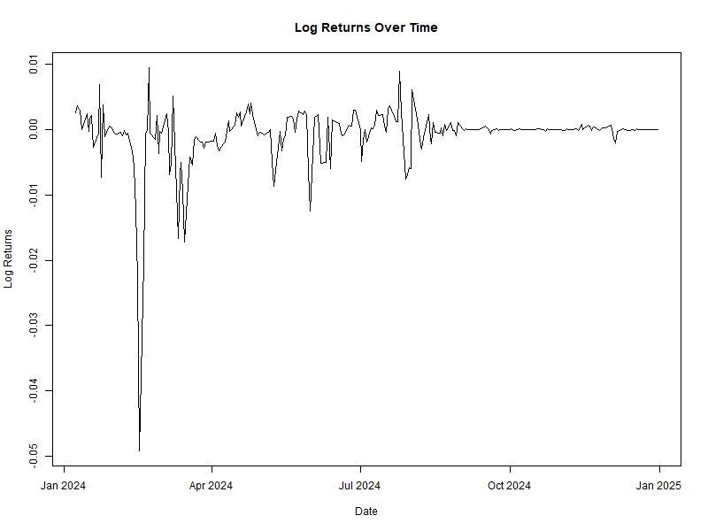

Figure 1. Plot of log returns

For the log returns of the data the Augmented Dickey-Fuller test confirmed stationarity with P-values of 0.01 for all log returns. In addition to this, ARCH-LM tests were conducted to confirm the presence of volatility clustering before the fitting and forecasting began. These tests confirmed that the data exhibited volatility clustering. This made it appropriate for us to use the GARCH-family models.

## DCC-MGARCH

The DCC-MGARCH model is particularly useful when comparing the dynamic relationships between multiple financial series. It was estimated to capture the time-varying volatility and correlations between two exchange rate series. The first exchange rate series was the log difference of the exchange data while the second series was the second differencing of the log returns. The log returns were shown as follows;

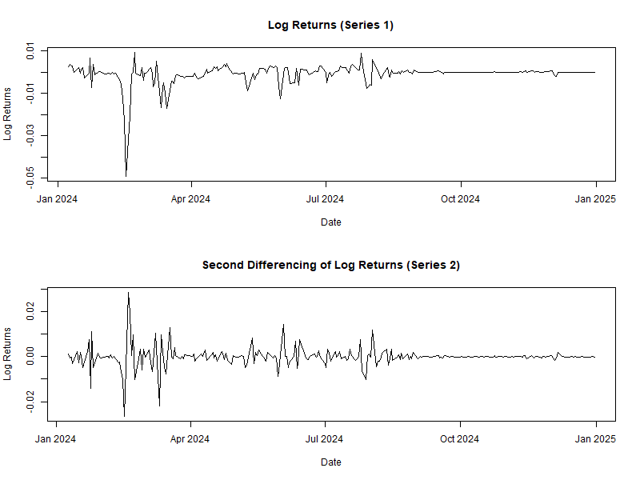

Figure 2. log returns plots for series 1 and 2

It is clear that in the two series there are big outliers with series one having a bigger drop in early 2024. In the second differencing there is a change such that due to the differencing the huge outlier has been shrunk exposing the consequent increase after the drop. However, despite these huge movements in the market there are periods of tranquility from August indicating that the market movements reduces and there is calmness towards the end of the year.

**Model specification and diagnostics**

From the *auto.garch* function, two univariate models were selected based on the criteria selected. The first univariate model for series 1had the following specifications; ARMA Order (0, 1), GARCH Order (1, 1), and with a GED as its best distribution. Series 2 had the following specifications; ARMA Order (1, 1), GARCH Order (1, 1) and a GED distribution. Since these specifications were selected with the guidance of AIC, series 1 had an AIC of -10.3557 while series 2 had an AIC of -10.268607. after fitting the model, the ARCH tests p-values for series1 were 0.287 while that of series 2 was 0.221. this suggests that the model adequately captures volatility clustering that was present in the data.

**Model forecasting**

The forecasted volatilities of the two series are show as follows;

|  |  |  |
| --- | --- | --- |
| Time | Volatility_1 | Volatility_2 |
| T+1 | 0.00014224 | 0.00047917 |
| T+2 | 0.000143821 | 0.000470586 |
| T+3 | 0.000145359 | 0.000462185 |
| T+4 | 0.000146855 | 0.000453964 |
| T+5 | 0.00014831 | 0.000445918 |
| T+6 | 0.000149728 | 0.000438046 |
| T+7 | 0.000151108 | 0.000430343 |
| T+8 | 0.000152453 | 0.000422806 |
| T+9 | 0.000153763 | 0.000415433 |
| T+10 | 0.000155041 | 0.000408221 |

Figure 3. table of forecasted volatilities

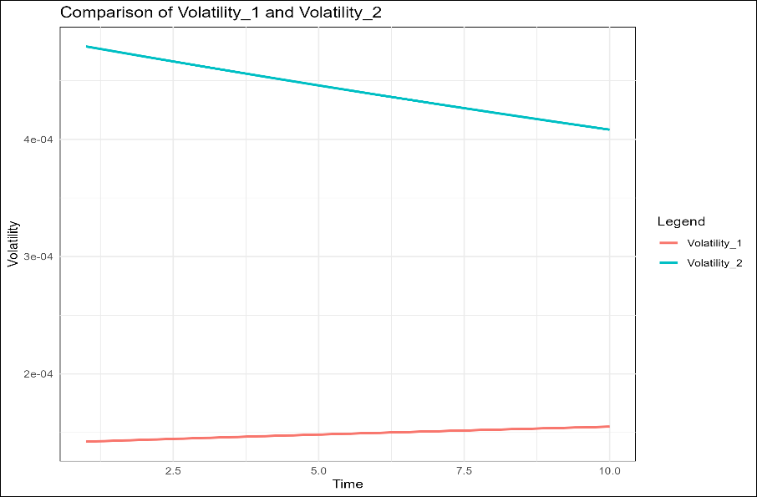

Figure 4 graph of the forecasted volatilities

The forecasted volatilities for the two series differ in a way that the volatilities for series 1 increases over time from 0.000142 to 0.000155 while the volatilities for series 2 decreases over time from 0.00047917. this indicates that the market expects some movements in the near future. The slight increase in series 1 indicates that there is stability in the market while the decrease in volatility of series 2 indicates that there is a reduction in uncertainty in the market for the second asset. From Figure 4 it is clear that the there is a huge difference between the two forecasts as series1 has higher forecasted volatilities is higher than that of series2, this might indicate that different market dynamics are affecting the two series. However, they are moving towards each other which means at some point they would cross.

**Correlation**

The possibility of the two forecasted volatilities crossing indicates that there is a correlation between them. These time varying correlations between the two series shown an increasing trend beginning from 0.075 at the 1st period to 0.112 at the 10th period. This indicates that the relationship between the two series strengthens over time. The increasing correlation also indicates that the two series become more interdependent overtime. This could be due to some macroeconomic factors or market integration. The forecasted correlation is shown in the figure below;

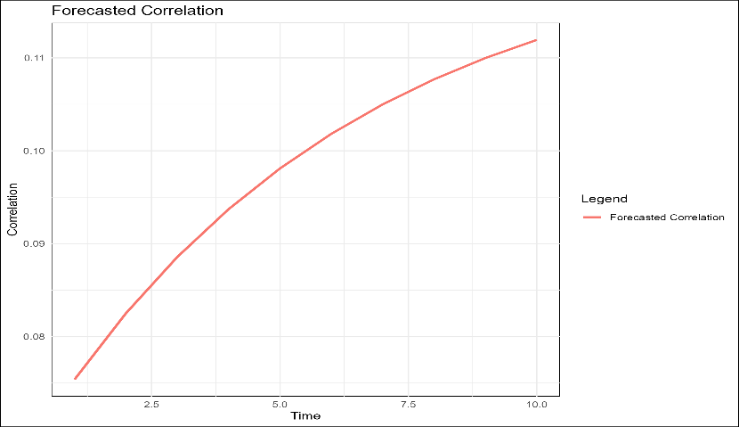

Figure 5Forecasted correlation

**Residuals**

Although the model captures volatility clustering adequately, Figure 6 contains the ACF of residuals plots for the two series. We could notice some spikes especially in the beginning, this means that model might have failed to capture some of the autocorrelations present in the data. This means that the model cold be improved further.

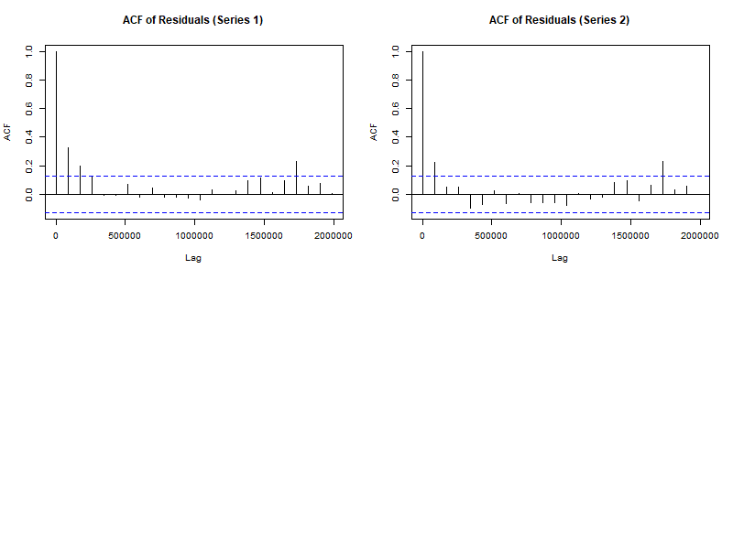

Figure 6 DCC GARCH ACF OF RESIDUALS

## SGARCH model results

**Model specification and diagnostics**

The SGARCH model was estimated to capture some of the standard volatility dynamics. It wasn’t meant to account for asymmetry or any power transformations. The best fitting model was selected primarily based on the AIC and the BIC provided secondary constraints for model selection. The model chosen had an ARMA order of (1, 1), GARCH Order of (1, 2) and uses the GED (Generalized error distribution). It had an AIC of -10.353 and a BIC of -10.239. this suggests that it was a good fit. The ADF test had p-values of 0.01, this confirms that the log returns were stationary. An ARCH test was conducted and had p-values of 0.0287. this confirms that the model captured the volatility clustering adequately.

**Model forecasting**

After forecasting, there was an indication of a significant spike in volatility. Initially it peaked before it gradually stabilized. This indicates that there would be a period of high uncertainty in the currency exchange market which will be followed by a return to normality for the volatility levels. From such a prediction, the predictive ability of this models seems somehow reasonable since it captures key trends and volatility dynamics well, especially in periods of increased uncertainty.

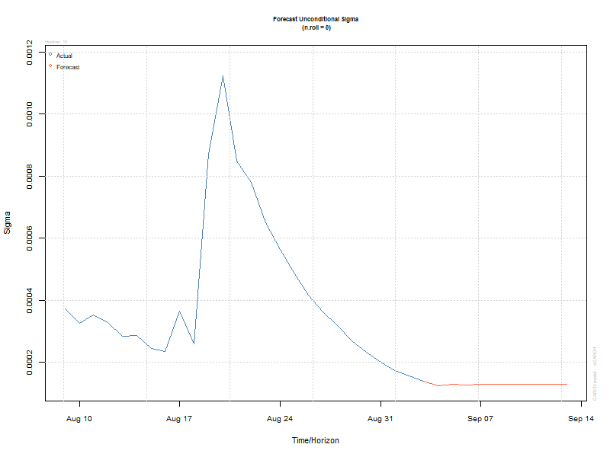

Figure 7SGARCH forecast volatility graph

The graph is supported by the volatility forecast table to show the forecasted volatility values and mean values.

|  |  |  |
| --- | --- | --- |
| Time | Forecasted Values | Forecasted Volatility |
| t+1 | -0.000003 | 0.000123 |
| t+2 | 0.000003 | 0.000128 |
| t+3 | 0.000006 | 0.000127 |
| t+4 | 0.000007 | 0.000128 |
| t+5 | 0.000008 | 0.000128 |
| t+6 | 0.000008 | 0.000128 |
| t+7 | 0.000008 | 0.000129 |
| t+8 | 0.000008 | 0.000129 |
| t+9 | 0.000008 | 0.000129 |
| t+10 | 0.000008 | 0.000130 |

Figure 8 SGARCH TABLE OF FORECASTS

**Residuals**

The ACF of residuals from this model suggests most of the lags fall within the required confidence bands. This implies the residuals contains little autocorrelation. However, there are few significant spikes that indicate the presence of minor dependencies that remains. From this we can conclude that there are opportunities for further model improvements.

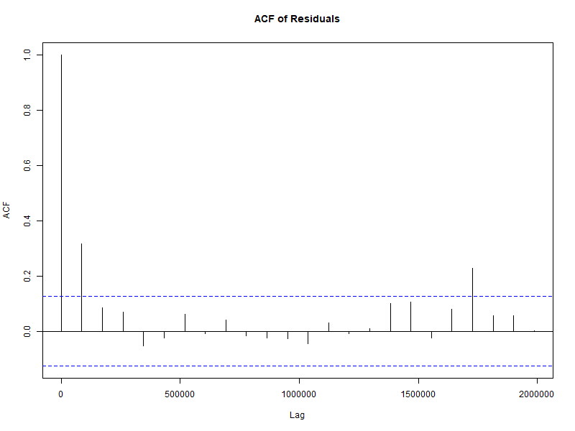

Figure 9 SGARCH ACF of residuals

The residuals are further shown through a histogram, density plot and Q-Q plot. The histogram and the density plot of residuals indicates a heavy-tailed distribution (fat-tails). This is a very common feature in financial time series. It also justifies the consideration of both the GED and students t distribution. The Q-Q plots indicates that there are deviations from normality. This suggests that there could be potential skewness or excess kurtosis. This implies that although the SGARCH model captures volatility dynamics or clustering effectively, it could still benefit from refinements.

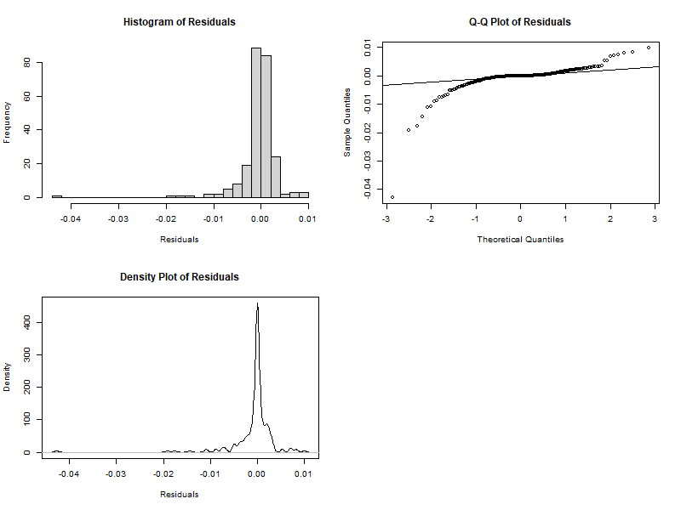

Figure 10 SGARCH RESIDUALS

## PGARCH (APARCH) model results

**Model specification and diagnostics**

The flexibility of the PGARCH model in modeling power-transformed volatility makes it suitable for capturing the nonlinear effects in the data. This allows for more flexibility in modeling the impact of shocks. The best model selected had the following specifications; ARMA Order (0, 1), GARCH Order (2, 1) and the best distribution was Generalized Error distribution. The AIC was -10.424 and BIC was -10.281. Such low AIC and BIC indicates a good fit. The model diagnostics were based on the ADF and ARCH tests. The ADF had a p-value of 0.01 confirming the stationarity and the ARCH tests had a p-value of 0.164, indicating that the model captured volatility clustering adequately.

**Model forecasting**

From the forecasts, the forecasted values (mean) and volatilities (sigma) show that there is a gradual increase over time. This is consistent with the persistence of volatility in the exchange rate data. This implies that the uncertainty in exchange rate could potentially increase in the coming days. This is a very important insight when it comes to risk management. The forecast values are shown in the figures below:

|  |  |  |
| --- | --- | --- |
| Time | Forecasted Values | Forecasted Volatility |
| t+1 | -0.000001 | 0.000178 |
| t+2 | 0.000002 | 0.000191 |
| t+3 | 0.000004 | 0.000221 |
| t+4 | 0.000006 | 0.000251 |
| t+5 | 0.000007 | 0.000281 |
| t+6 | 0.000007 | 0.000312 |
| t+7 | 0.000008 | 0.000343 |
| t+8 | 0.000008 | 0.000374 |
| t+9 | 0.000008 | 0.000406 |
| t+10 | 0.000009 | 0.000439 |

Figure 11 PGARCH TABLE OF FORECASTS

The graph of the forecasts is as follows:

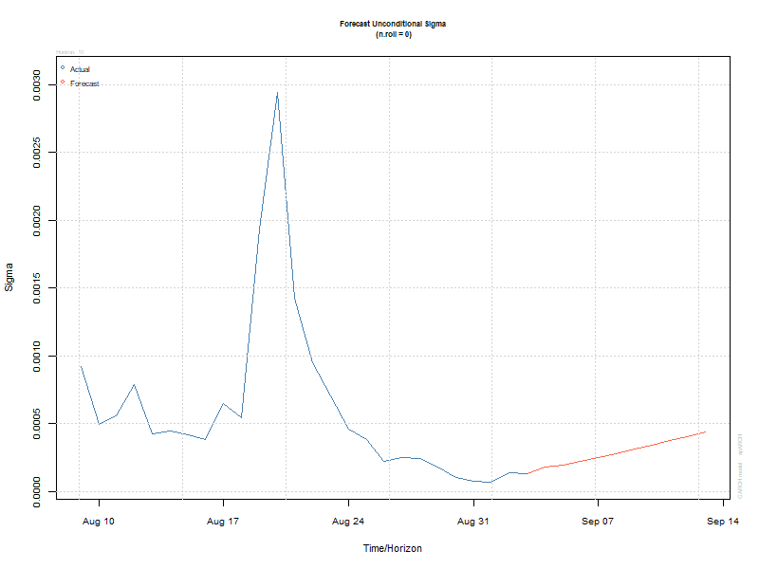

Figure 12 PGARCH FORECAST GRAPH

This plot displays how conditional variance evolves over time. The model successfully captures the volatility clustering effect, where a high volatility is followed by a gradual decline. However, when it comes to future volatility (red line), it shows an increasing trend suggesting increased uncertainty in the near future.

**Residuals**

The ACF of residuals plot indicates significant spikes in the first few lags. This indicates that some autocorrelations still remain in the residuals. From this it is clear that the PGARCH model did not completely remove the serial dependencies. This implies that further refinement or alternative specifications might be needed to improve the model.

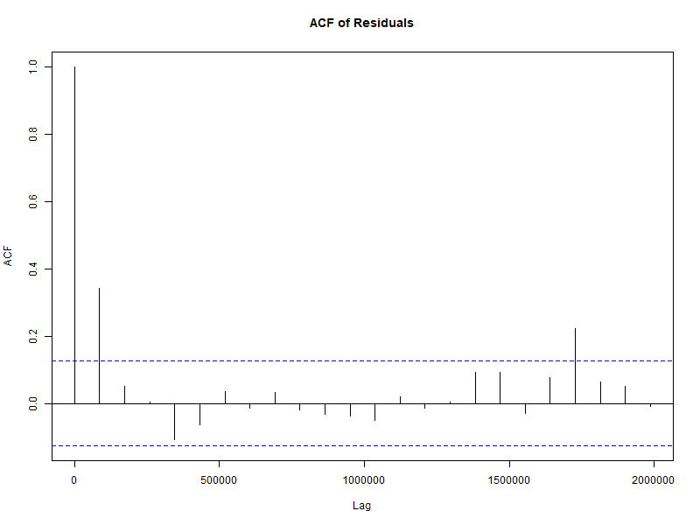

Figure 13 PGARCH ACF OF RESIDUALS

The histogram of residuals appears to be skewed, with most of the values concentrated around zero but there are no noticeable outliers. The density plot confirms that the residuals are peaked, showing a great concentration bear zero but with substantial tail events. From the Q-Q plot we observe that the residuals are deviating from the normal distribution especially in the tails. This suggests the presence of heavy tails, common to financial data.

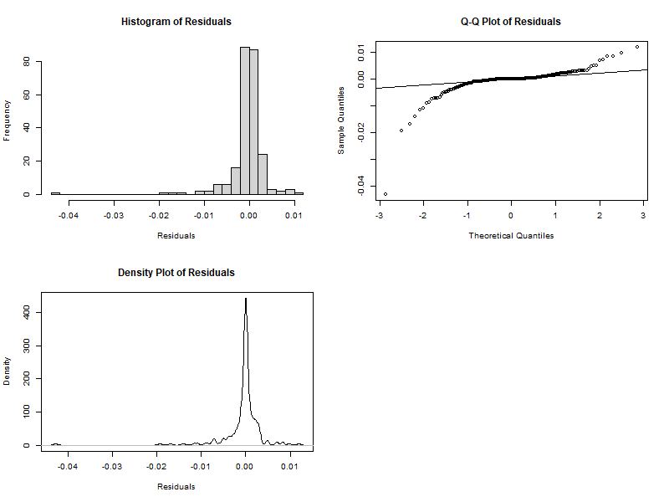

Figure 14 PGARCH PLOT OF RESIDUALS

## TGARCH model results

**Model specification and diagnostics**

The ability of the TGARCH to capture the asymmetric effects makes it very useful for modelling financial data where negative shocks (bad news) may have a greater impact on volatility than positive shocks (good news). This model is best suited for when it is critical to capture asymmetry such as during the downturns of markets. The best fitted model specifications was as follows: ARMA order of (1, 2), GARCH order of (1, 1) and the Generalized Error Distribution (GED). The AIC of this model was -10.486 and the BIC was -10.357 suggesting that it was a good fit. The model diagnostics was as follows: the ADF test had p-values of 0.01 confirming stationarity and the ARCH test had a p-value of 0.01 confirming that the model adequately captured volatility clustering.

**Model forecasting**

The forecasted values and volatilities showed a gradual increase overtime. This is consistent with the persistence of volatility in the exchange rate data.

|  |  |  |
| --- | --- | --- |
| Time | Forecasted Values | Forecasted Volatility |
| t+1 | -0.000013 | 0.000133 |
| t+2 | 0.000003 | 0.000152 |
| t+3 | 0.000005 | 0.000170 |
| t+4 | 0.000007 | 0.000189 |
| t+5 | 0.000009 | 0.000207 |
| t+6 | 0.000010 | 0.000225 |
| t+7 | 0.000012 | 0.000244 |
| t+8 | 0.000013 | 0.000262 |
| t+9 | 0.000014 | 0.000281 |
| t+10 | 0.000015 | 0.000299 |

Figure 15 TGARCH TABLE OF FORECASTS

In the forecast volatility plot, it seems to capture the general pattern but seems to underestimate the spikes in volatility. The red line (forecasted volatility) appears to be increasing slightly. This suggests that the model is detecting some persistence in volatility and suggests an increase in market uncertainties.

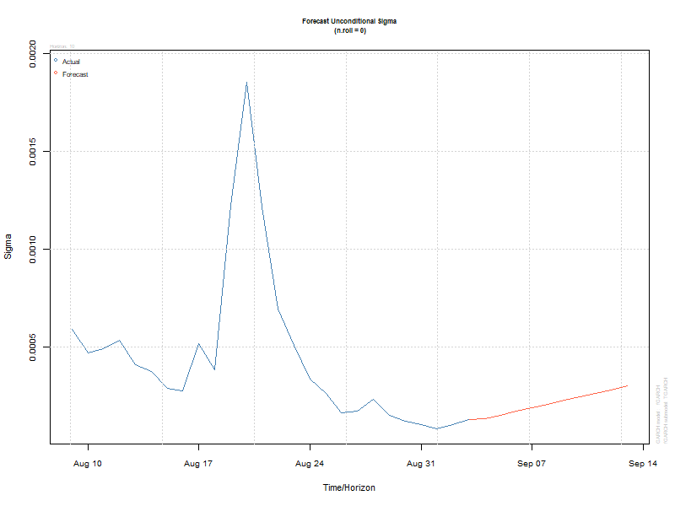

Figure 16 TGARCH PLOT OF FORECASTS

**Residuals**

The ACF of residuals indicate a significant autocorrelation at lag 1 and a few other lags. This suggests the presence of remaining structure in the residuals. Normally residuals behave like white noise, meaning most of the auto correlations should be within the confidence bands. However, some spikes exceed the confidence bands in our model. This suggests that volatility clustering might not be fully captured meaning that there is an opportunity for further improvement.

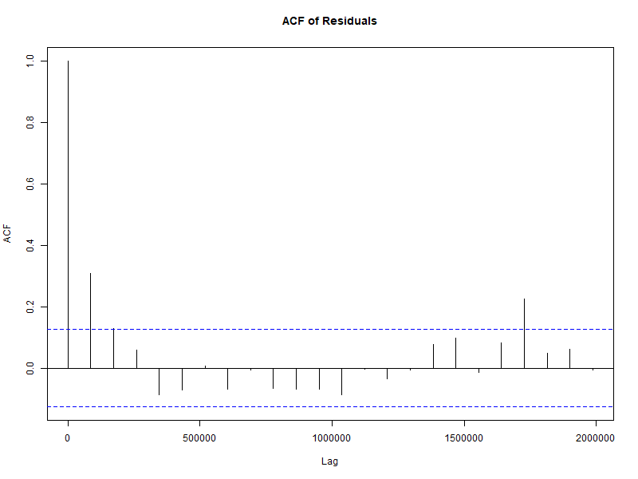

Figure 17 TGARCH ACF OF RESIDUALS

The other residual diagnostics included a histogram, density plot and Q-Q plot of residuals. The histogram indicates that the residuals are highly peaked, suggesting existence of fat -tails. The density plot shows a sharp peak and heavy tails, confirming that they are not normally distributed. The Q-Q plot indicate that the residuals deviate from the normal line, specifically in the tails. This reinforces our choice of students t and Generalized error distributions.

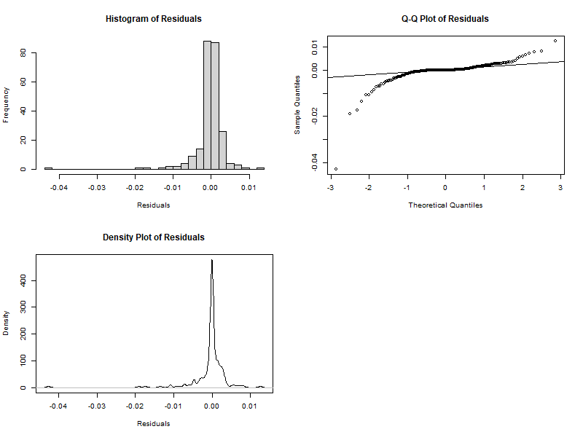

Figure 18 TGARCH PLOTS OF RESIDUALS

## EGARCH model of results

**Model specification and diagnostics**

This model was estimated to capture the asymmetric effects of shocks on the volatility. The logarithmic transformation ensure that volatility is always positive, this makes it robust for modeling financial data. This model is specifically useful for applications where both asymmetry and robustness are crucial such as option pricing. The best fitted model was selected using AIC (Akaike Information Criterion) as the primary basis of selection. The chosen model had the following specifications; ARMA order of (1, 2), GARCH order of (2, 1) and uses a Generalized Error Distribution. The model was a good fit since it had AIC values of -10.515 and BIC values of -10.357. For the model diagnostics the ARCH test had p-values of 0.086 suggesting that it adequately captures volatility clustering while the ADF test had p-values of 0.01 confirming stationarity.

**Model forecasting**

The forecasted values and volatilities show a gradual increase over time. This is consistent with the persistence of volatility in the exchange rate data. The forecasted volatility (unconditional sigma) shows a very sharp peak that is followed by a declining trend before it stabilizes in the long run. This suggests that the model captures the volatility clustering effectively whereby the high volatility is succeeded by a gradual return to normal levels. Such a forecasting behavior aligns with the characteristics of financial time series where periods of high uncertainty are usually followed by a mean reverting volatility.

|  |  |  |
| --- | --- | --- |
| Time | Forecasted Values | Forecasted Volatility |
| t+1 | -0.000003 | 0.000090 |
| t+2 | 0.000007 | 0.000080 |
| t+3 | 0.000007 | 0.000080 |
| t+4 | 0.000008 | 0.000080 |
| t+5 | 0.000008 | 0.000081 |
| t+6 | 0.000009 | 0.000081 |
| t+7 | 0.000009 | 0.000081 |
| t+8 | 0.000010 | 0.000082 |
| t+9 | 0.000010 | 0.000082 |
| t+10 | 0.000011 | 0.000082 |

Figure 19 EGARCH TABLE OF FORECASTS

The forecast plot is as shown:

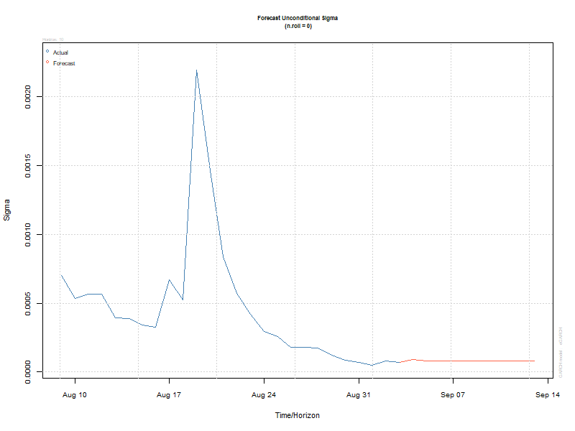

Figure 20 EGARCH FORECASTS PLOT

**Residuals**

The ACF plot of residuals displays some significant spikes especially at the lower lags. For a well specified GARCH model, the residuals should have been uncorrelated. The presence of these spikes indicates that there exists some autocorrelation in the residuals. This implies that the model could have not fully captured all the patterns in volatility.

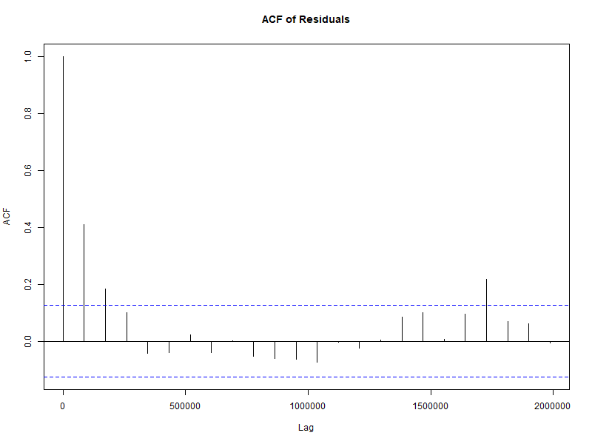

Figure 21 EGARCH ACF OF RESIDUALS

Additional residual analysis using histogram density plot and Q-Q plot of residuals were used. The histogram shows a heavy concentration around zero with a noticeable skewness and potential heavy tails. The density plot shows a sharp peak at zero and fat tails that reinforce non-normality (common in financial data). The Q-Q plots indicate that the residuals deviate from the normal distribution especially in the tails. This implies that there exists excess kurtosis.

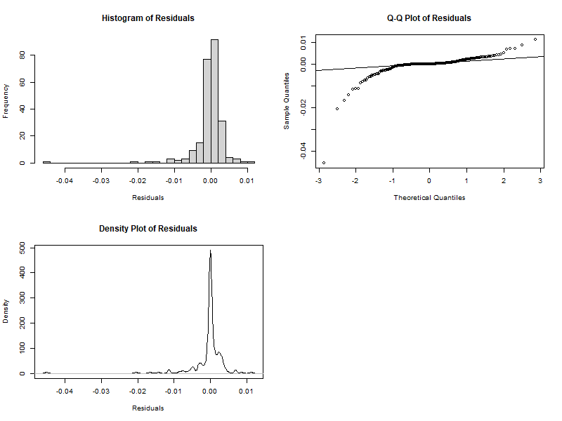

Figure 22 EGARCH PLOT OF RESIDUALS

## Model forecast validation

The performance of the models in forecasting was assessed and evaluated using three key metrics: Root Mean Squared Error (RMSE), Mean Absolute Percentage Error (MAPE) and Directional Accuracy (DA). The results are shown below:

|  |  |  |  |  |
| --- | --- | --- | --- | --- |
| Position | Model | RMSE | MAPE | DA |
| 1 | DCC-MGARCH Volatility_1 | 8.750993e-05 | 45.67497 | 44.44444 |
| 2 | SGARCH | 9.550498e-05 | 39.36934 | 66.66667 |
| 3 | PGARCH | 9.579555e-05 | 56.05875 | 44.44444 |
| 4 | TGARCH | 1.200346e-04 | 88.77787 | 44.44444 |
| 5 | EGARCH | 1.267033e-04 | 44.28130 | 33.33333 |
| 6 | DCC-MGARCH Volatility_2 | 2.678426e-04 | 207.09159 | 33.33333 |

**RMSE**: The DCC-MGARCH series 1 has the lowest RMSE (8.750993e-05). This indicates it has the highest accuracy when forecasting volatility.

**MAPE**: The SGARCH model had the lowest MAPE (39.36934). this suggests that it has the smallest percentage error in its forecasts.

**DA**: The SGARCH model has the highest DA (66.66667). this indicates that it has the best directional accuracy.

## Discussion of findings

The results have highlighted the importance of using advanced GARCH models in capturing the complex dynamics of exchange rate volatility. The DCC-MGARCH is useful especially for analyzing time-varying correlations. The remaining are particularly useful in providing useful insights into standard, power-transformed and asymmetric volatility effects. These findings have important effects on risk management and financial decision making;

The key insights from the analysis include:

* **Volatility clustering**; all the models have effectively captured volatility clustering which is a common feature of financial time series.
* **Asymmetric effects**: the TGARCH and EGARCH models are effective especially in capturing asymmetric effects, where negative shocks have a bigger impact on volatility compared to the positive shocks.
* **Correlation dynamics**: the DCC-MGARCH model has provided valuable insights into the time-varying correlations between the exchange rate series. This is important in portfolio management and hedging strategies.
* **Model fit and residual analysis**: all the models performed really well in capturing volatility clustering. This implies that the fitting was done well. However, residual diagnostics indicate that autocorrelation existed in all the models fitted. This study dealt with specifically three distributions, the normal distribution, students t distribution and the Generalized error distribution. The GED and the students t are effective when it comes to fat tails in financial data. They should have been sufficient in removing all dependencies and auto correlation. The few spikes in the lags were due to the existence of skewness and excess kurtosis. This explains the failure of the GED distributions in capturing all autocorrelation. Excess kurtosis and skewness are majorly modelled by skewed GED or skewed students t distributions.
* **Model forecast validation:** the validation results highlight the trade-offs between factors such as accuracy, percentage error and directional accuracy. Although the DCC-MGARCH model was the most accurate based on RMSE, the SGARCH model performs best in DA and is second best in RMSE. This makes it suitable when predicting the direction of volatility changes. this is more important than focusing on precises volatility magnitude.

# CHAPTER 5: CONCLUSION AND RECOMMENDATIONS

## Introduction

This chapter summarized the findings from the study, discusses their implications and provides recommendations for future research and practical applications. The objective of this study was to model and forecast the volatility of the KES/USD exchange rate using various GARCH models. These models include SGARCH, PGARCH, EGARCH, TGARCH and the DCC-MGARCH. The results provided some valuable insights into the dynamics of the exchange rate volatility and the performance of each of the models in capturing volatility dynamics.

## Summary of the findings

The following are the key findings yielded from the study:

Volatility clustering: all the models in the study captured volatility clustering, this is a common feature of financial time series and data. This confirms that the GARCH family models used were suitable for modelling the exchange rate volatility.

## Model performance:

* **DCC-MGARCH:** this model performed fairly well in capturing time varying correlations between exchange rate series. The series 1 had the lowest RMSE (8.750993e-05). However, its series 2 had the highest MAPE of (207.09159) suggesting that it has limitations in forecasting events with extreme volatility.
* **SGARCH**: this model had the highest directional accuracy (DA=66.66667), with impressive results on RMSE and MAPE. This makes it suitable for applications where predicting the direction of volatility changes is critical.
* **EGARCH**: this model effectively captured the asymmetric effects and had a low RMSE of 1.267033e-04 and MAPE of 44.28130 in comparison to TGARCH. This makes it quite robust for applications in markets such as option pricing.
* **TGARCH**: this model proved to be effective in capturing asymmetric effects, however, it had the highest MAPE of 88.77787. this suggests it had challenges forecasting extreme events.
* **PGARCH**: this model provided flexibility in modeling power transformed volatilities. However, it showed signs of more residual autocorrelation compared to the other models. This indicates that it could benefit from further improvements.

## Residual diagnostics

The residual analysis (histogram. Density plot and Q-Q plot of residuals) revealed the presence of heavy tails and non-normality in most models. There also existed skewness and excess kurtosis, indicating that alternative error distributions such as skewed students t or skewed GED or any other distributions that assess kurtosis and skewness could improve the fit. The study only worked with students t, normal and GED distributions but specifically GED which could explain the residual autocorrelation noticed in the ACF plots of residuals for most models. This is due to the existing skewness and kurtosis that wasn’t accounted for.

## Forecasting accuracy

The DCC-MGARCH model, particularly series 1, had the best accuracy results in terms of RMSE while the SGARCH model had the best and highest directional accuracy. The EGARCH model on the other hand had a balance on robustness and accuracy, which makes it a strong candidate for all practical applications. The SGARCH was generally the best in terms of forecasting.

## significance of the findings;

The findings have various significance on subjects of financial modeling, risk management and decision making

* **Risk management:** The GARCH models have the ability to capture volatility clustering and asymmetric effects. This makes them a valuable tool for risk management. An example of real-world application of this is that the EGARCH and TGARCH models can help financial institutions assess the impact of negative shocks on volatility. This is very critical when stress testing and performing scenario analysis.
* **Portfolio management:** the DCC-MGARCH model has the ability to capture time-varying volatility between multiple exchange rate series. This is particularly useful for portfolio management and hedging strategies. Investors could use the insights from this model to optimize their portfolios and reduce exposure to currency risk.
* **Trading strategies:** the SGARCH model showed high directional accuracy. This makes it suitable for designing and developing trading strategies that rely on predicting the direction of volatility changes. Traders could utilize this model to identify periods of low or high volatility and adjust their positions accordingly.
* **Significance on policies:** policymakers could utilize the insights from this study to monitor the volatility of exchange rates and implement measures to stabilize the currency market. For instance, understanding the dynamics of volatility clustering could help central banks develop effective intervention strategies.

## Limitations of the study

The study only considers a single year of daily exchange rate data particularly the year 2024. Considering a longer dataset could provide more robust results and allow for the analysis of regime shifts and structural breaks. Some of the models used such as DCC-MGARCH are computationally intensive and requires more effort and modelling time. This makes could be hard for some users. GARCH models usually assume linear relationships between the variables involved. It would benefit to consider non-linear models such as regime switching GARCH to capture some of the more complex dynamics. There was a huge outlier in the data due to the huge movement in early 2024, however this study did not put in palace strategies to deal with the outliers.

## Recommendations

Based on the findings, we could make the following recommendations;

* **Model refinement;** future studies could explore the use of alternative error distribution meant to deal with skewness and excess kurtosis such as the skewed students t distribution and skewed GED among others. To improve forecasting accuracy, hybrid models that combine GARCH with machine learning techniques such as the use of neural networks.
* **Incorporation of external variables**: including macroeconomic variables (external) could improve and enhance the predictive power of the models. This would provide a more comprehensive understanding of the factors that drive exchange rate volatility.
* **Longer forecasting horizons (n rolls):** this study focuses on a short-term forecast (10-day). Future research could explore longer forecasting horizons to asses the performance of the models in capturing medium- and long-term volatility patterns.
* **Dealing with outliers**: future studies would benefit from implementing strategies to deal with outliers such as Winsorization or interpolation.
* **Comparative studies:** the comparative studies that involve other currencies or financial assets could provide additional insights into the generalizability of the findings. For instance, the same methodology could be applied to other emerging market currencies, this would reveal some of the common patterns and even unique characteristics.
* **Practical applications**: traders and financial institutions should consider using a combination of these models. For instance, they could employ SGARCH for directional accuracy, EGARCH for robustness and DCC-MGARCH for time-varying volatilities. This would serve to improve decision making and risk management.

## Conclusion

This study has demonstrated the effectiveness of GARCH models in capturing and forecasting the volatility of the KES/USD exchange rate. The DCC-MGARCH, SGARCH, EGARCH, TGARCH AND PGARCH models all have their own unique strengths and limitations. This makes the suitable for different applications in the financial market as a whole. The findings highlight the importance of model selection, diagnostic testing and validation of forecasts in ensuring reliable and accurate forecasts.

The study serves to contribute into the growing literature surrounding finance and exchange rate volatility. Ot also provides practical insights for financial institutions, policy makers and traders. By addressing the limitations and exploring the recommendations mentioned in this chapter, future research can advance further our understanding of the exchange rate dynamics and improve the tools available for managing currency risk.

# References

1. Bachelier, L. (1900). Théorie de la Spéculation, Gauthier-Villars. *DOI: https://doi. org/10.24033/asens*, *476*.
2. Bollerslev, T. (1986). Generalized autoregressive conditional heteroskedasticity. *Journal of econometrics*, *31*(3), 307-327.
3. Engle, R. F. (1982). Autoregressive conditional heteroscedasticity with estimates of the variance of United Kingdom inflation. *Econometrica: Journal of the econometric society*, 987-1007.
4. Fama, E. F. (1965). The behavior of stock-market prices. *The journal of Business*, *38*(1), 34-105.
5. Meese, R. A., & Rogoff, K. (1983). Empirical exchange rate models of the seventies: Do they fit out of sample?. *Journal of international economics*, *14*(1-2), 3-24.
6. Samuelson, P. A. (1965). A theory of induced innovation along Kennedy-Weisäcker lines. *The Review of Economics and Statistics*, 343-356.
7. Cipollini, F., & Gallo, G. M. (2019). Modeling the volatility of exchange rate currency using GARCH models. International Journal of Empirical Finance, 7(1), 1–15.
8. Epaphra, M. (2017). Modeling exchange rate volatility: Application of the GARCH and EGARCH models. Journal of Mathematical Finance, 7(1), 121–143. https://doi.org/10.4236/jmf.2017.71007
9. Johnston, K., & Scott, E. (2000). GARCH models and the stochastic process underlying exchange rate price changes. Journal of Financial and Strategic Decisions, 13(2), 13–24.
10. Avilés Ochoa, E., & Flores Sosa, M. (2021). Comparison of the GARCH and stochastic volatility models in exchange rate. [Journal Name, Volume(Issue), Pages].
11. Baillie, R. T., & Bollerslev, T. (1989). The message in daily exchange rates: A conditional-variance tale. Journal of Business & Economic Statistics, 7(3), 297–305.
12. Chortareas, G., Kapetanios, G., & Shin, Y. (2011). Financial market efficiency and exchange rates: Evidence from nonlinear unit root tests. Journal of International Money and Finance, 30(2), 409–427.
13. Lo, A. W. (2004). The adaptive markets hypothesis: Market efficiency from an evolutionary perspective. The Journal of Portfolio Management, 30(5), 15–29.
14. Malkiel, B. G. (2003). The efficient market hypothesis and its critics. Journal of Economic Perspectives, 17(1), 59–82.
15. Menkhoff, L., & Taylor, M. P. (2007). The obstinate passion of foreign exchange professionals: Technical analysis. Journal of Economic Literature, 45(4), 936–972.
16. Bollerslev, T. (1990). Modelling the coherence in short run nominal exchange rates. Review of Economics and Statistics, 72(3), 498–505.
17. Mandelbrot, B. (1963). The variation of speculative prices. The Journal of Business, 36(3), 394–412.
18. Nelson, D. B. (1991). Conditional heteroscedasticity in asset returns: A new approach. Econometrica, 59(2), 347–370.
19. Zakoian, J. M. (1994). Threshold ARCH models. Journal of Economic Dynamics and Control, 18(2), 253–275
20. Abdalla, S. Z. S. (2012). Modelling exchange rate volatility using GARCH models: Empirical evidence from Arab countries. *International Journal of Economics and Finance*, *4*(3), 216-229.
21. Dukich, J., Kim, K. Y., & Lin, H. H. (2010). Modeling exchange rates using the GARCH Model. *Work. Paper*.
22. Omari, C. O., Mwita, P. N., & Waititu, A. G. (2017). Modeling USD/KES exchange rate volatility using GARCH models.
23. Murari, K. (2015). Exchange rate volatility estimation using GARCH models, with special reference to Indian rupee against world currencies. *IUP Journal of Applied Finance*, *21*(1), 22.
24. Musa, Y., Tasi'u, M., & Bello, A. (2014). Forecasting of exchange rate volatility between Naira and US Dollar using GARCH models. *International Journal of Academic Research in Business and Social Sciences*, *4*(7), 369.
25. Abdullah, S. M., Siddiqua, S., Siddiquee, M. S. H., & Hossain, N. (2017). Modeling and forecasting exchange rate volatility in Bangladesh using GARCH models: a comparison based on normal and Student’st-error distribution. *Financial Innovation*, *3*, 1-19.
26. Bošnjak, M., Bilas, V., & Novak, I. (2016). Modeling exchange rate volatilities in Croatia. *Ekonomski vjesnik/Econviews-Review of Contemporary Business, Entrepreneurship and Economic Issues*, *29*(1), 81-94.
27. Yussif, A. R. B., Onifade, S. T., Ay, A., Canitez, M., & Bekun, F. V. (2024). Modeling the volatility of exchange rate and international trade in Ghana: empirical evidence from GARCH and EGARCH. *Journal of Economic and Administrative Sciences*, *40*(2), 308-324.
28. Epaphra, M. (2016). Modeling exchange rate volatility: Application of the GARCH and EGARCH models. *Journal of Mathematical Finance*, *7*(1), 121-143.
29. Dritsaki, C. (2019). MODELING THE VOLATILITY OF EXCHANGE RATE CURRENCY USING GARCH MODEL. *International Economics/Economia Internazionale*, *72*(2).
30. Longmore, R., & Robinson, W. (2004). Modelling and forecasting exchange rate dynamics: an application of asymmetric volatility models. *Bank of Jamaica, Working Paper, WP2004*, *3*, 191-217.
31. Nortey, E. N., Ngoh, D. D., Doku-Amponsah, K., & Ofori-Boateng, K. (2015). Modeling inflation rates and exchange rates in Ghana: application of multivariate GARCH models. *SpringerPlus*, *4*, 1-10.
32. Sabina, N. E., Manyo, T. S., & Ugochukwu, U. S. (2017). Modeling exchange rate volatility and economic growth in Nigeria. *Noble International Journal of Economics and Financial Research*, *2*(6), 88-97.
33. Chong, C. W., Chun, L. S., & Ahmad, M. I. (2002). Modeling the volatility of currency exchange rate using GARCH model. *Petranka Journal of Social Science & Humanities*, *10*(2), 85-95.
34. May, C., & Farrell, G. (2018). Modelling exchange rate volatility dynamics: Empirical evidence from South Africa. *Studies in Economics and Econometrics*, *42*(3), 71-113.
35. Yıldırım, E., & Cengiz, M. A. (2022). Modeling and Forecasting of USD/TRY Exchange Rate Using ARMA-GARCH Approach. *İstatistik Araştırma Dergisi*, *12*(2), 1-13.
36. Marreh, S., Olubusoye, O. E., & Kihoro, J. M. (2015). Modeling volatility in the Gambian exchange rates: An ARMA-GARCH approach.
37. Charef, F., & Ayachi, F. (2016). A Comparison between neural networks and GARCH models in exchange rate forecasting. *International Journal of Academic Research in Accounting, Finance and Management Sciences*, *6*(1), 94-99.
38. Brooks, C. (2001). A double‐threshold GARCH model for the French Franc/Deutschmark exchange rate. *Journal of Forecasting*, *20*(2), 135-143.
39. Lahmiri, S. (2017). Modeling and predicting historical volatility in exchange rate markets. *Physica A: Statistical Mechanics and its Applications*, *471*, 387-395.
40. Bollerslev, T. (1986). Generalized autoregressive conditional heteroskedasticity. *Journal of econometrics*, *31*(3), 307-327.
41. Engle, R. F. (1982). Autoregressive conditional heteroscedasticity with estimates of the variance of United Kingdom inflation. *Econometrica: Journal of the econometric society*, 987-1007.
42. Kariuki, J. (2017). The impact of exchange rate volatility on economic growth in Kenya. *Journal of Economics and Finance, 5*(2), 45-63.
43. Kiptoo, N. (2023). *A history of Kapsowar Mission Hospital Elgeyo Marakwet County Kenya, 1934-2020* (Doctoral dissertation, Egerton University).
44. Mungai, K., & Wanjohi, E. (2023). Effects of US monetary policy on foreign exchange rates in Kenya. International Journal of Finance and Banking Studies, 11(3), 67-89.
45. Musyoki, D., Murigu, J., & Kamau, A. (2012). Volatility modeling of exchange rates in Kenya: A GARCH approach. *African Journal of Business Management, 6*(11), 4009-4018.
46. Mutisya, P., & Makau, D. (2016). Political instability and exchange rate fluctuations in Kenya. *Journal of African Economic Research, 7*(4), 92-110.
47. Ngugi, J., & Kariuki, L. (2020). Application of GARCH models in predicting exchange rate volatility in emerging markets. *Journal of Financial Analytics, 9*(2), 56-78.
48. Njoroge, M. (2019). Government debt and exchange rate depreciation: A Kenyan perspective. *Economic Policy Review, 6*(1), 31-50.
49. Omondi, P. (2020). The role of USD in Kenya’s foreign trade and economic stability. *East African Economic Review, 12*(2), 78-101.
50. Owino, S. (2021). The impact of global commodity prices on Kenya’s exchange rate volatility. Journal of African Markets and Trade, 10(3), 134-152.
51. Wekesa, T., & Were, P. (2022). The relationship between interest rates and foreign direct investment inflows in Kenya. Kenyan Journal of Economic Studies, 14(1), 23-40.